Name:………………………………………………………………Index No…………………..

Signature:………………………………………………………

P525/1
Chemistry
Paper 1
July/Aug. 2018
3¼ Hours

UGANDA ADVANCED CERTIFICATE OF EDUCATION
CHEMISTRY
PAPER 1
TIME: 3¼ HOURS

Instructions to Candidates

- Attempt all questions in Section A and any six from Section B
- All questions are to be answered in the spaces provided only
- A periodic table with relevant atomic masses is supplied at the end of the paper.

FOR Examiner’s use only
1 | 2 | 3 | 4 | 5 | 6 | 7 | 8 | 9 | 10 | 11 | 12 | 13 | 14 | 15 | 16 | 17 | TOTAL

SECTION A
Attempt all questions in this section (46marks)
- The figure below shows the pressure temperature curves for water
B

A
Pressure liquid
(mmHg) solid

•X vapour

C

0.01 Temperature (ºC)

O

- State the;
- equilibrium represented by point O (01 mark)
…………………………………………………………………………………………………………………………………………………………………………………….
- significance of point A (01 mark)
……………………………………………………………………………………………………………………………………………………………………………………
- Comment on the slope of line OB (02 marks)
………………………………………………………………………………………………………………………………………………………………………………………………………………………………………………………………………
- State what will happen to ice at point X if it’s gently heated while keeping the pressure constant.
…………………………………………………………………………………………………………………………………………………………………………………….
(01 mark)

- (a) Write equation(s) of reaction(s) between water and
- Phosphorus (III) chloride
………………………………………………………………………………………………………………………………………………………………………………
- Phosphorus (V) chloride
…………………………………………………………………………………………………………………………………………………………………………………….
(b) Explain why phosphorus (V) chloride can be formed but not nitrogen (V) chloride.

………………………………………………………………………………………………………………………………………………………………………………………………………………………………………………………………………………………………………………………………………………………………………………………………………………………………………………………………………………………………………………………………………………………………………………………………………………………………………………………………………………………………………………………………………………………………………………………………………………………………………………………………………………………………………………………………………………………………………………………………
(3½ marks)
- Complete the following equations and write the systematic name of the organic product.
- (CH₃CH₂)₂NH NaNO₂/HCl ……………………………………………
OºC
Name of product: …………………………………………………………………………………………
(01 mark)
- CH₃CH₂CHO NH₂OH/H⁺ ……………………………………………….

Name of product:
…………………………………………………………………………………………
(01 mark)

- CH₃CHCH₂COO–Na⁺ CaO ……………………………………………..
CH₃ heat
Name of product:
…………………………………………………………………………………………
(01 mark)
- (CH₃)₂C = CH₂ + HCl …………………………………………………….

Name of product:
………………………………………………………………………………………….
(01 mark)
- n(CH₂ = CCH = CH₂) …………………………………………………….
CH₃

Name of product:
………………………………………………………………………………………..
(01 mark)
- (a) 0.6g of iron (III) chloride in the gaseous state was found to occupy 200cm³ at 4.60 x 10^{– 4} Pa and 327ºC. Determine the molar mass of iron (III) chloride in the gaseous phase and comment on your value
(Fe = 56 Cl = 35.5)
……………………………………………………………………………………………………………………………………………………………………………………
……………………………………………………………………………………………………………………………………………………………………………………
(02 marks)
(b) Draw the structural formula of iron (III) chloride in the gaseous phase
……………………………………………………………………………………………………………………………………………………………………………………
…………………………………………………………………………………………
(01 mark)

(c) Write equation of reaction which takes place when iron (III) chloride is added to water.
…………………………………………………………………………………………………………………………………………………………………………………….
(01 mark)
- 29.5cm³ of nitric acid was gradually added to 50cm³ of 0.72M potassium hydroxide solution in a calorimeter of negligible heat capacity. If the temperature rise of solution was 6.4ºC; calculate the heat of neutralisation of nitric acid by potassium hydroxide. State the assumptions made. (Density of solution is 1gcm⁻³, specific heat capacity of solution is 4.2Jg^{-1ο}C⁻¹)
………………………………………………………………………………………………………………………………………………………………………………………………
…………………………………………………………………………………………………………………………………………………………………………………..……………………………………………………………………………………………………………………………………………………………………………………………………………………………………………………………………………………………………………………………………………………………………………
……………………………………………………………………………………………………………………………………………………………………………………
(5 ½ marks)
- (a) A synthetic rubber Q, was made from unknown number of monomers with the structural formula H₂C = C – C = CH₂
Cl H
- State the condition(s) for the reaction (01 mark)
……………………………………………………………………………………………………………………………………………………………………………………
- Write the equation for the reaction leading to the formation of Q
…………………………………………………………………………………………………………………………………………………………………………………… (01 mark)

(b) Name the type of reaction in a (i)
…………………………………………………………………………………………. ( ½ mark)
(c) A solution containing 5g of Q in 200cm³ of trichloro methane is found to have
an osmotic pressure of 34KPa at 17ºC. Determine the number of monomers in Q.
……………………………………………………………………………………………………………………………………………………………………………………
……………………………………………………………………………………………………………………………………………………………………………………
……………………………………………………………………………………………………………………………………………………………………………………
(2 ½ marks)
- (a) Define oxygen reacts with nitrogen according to the following equation
2NO_{(g)} + O_{2(g)} 2NO_{2(g)}
The following data was obtained for the above reaction
Experiment number | [0₂] x 10^{– 2} moldm^{– 3} | [NO₂] x 10 ^{– 2} moldm ^{– 3} | Rate of disappearance of [NO] x 10 ^{– 4} moldm^{– 3} S ^{– 1}
1 | 1.0 | 1.0 | 0.7
2 | 1.0 | 2.0 | 2.8
3 | 1.0 | 3.0 | 6.3
4 | 2.0 | 2.0 | 5.6
5 | 3.0 | 3.0 | 18.9

- Deduce the order of reaction with respect to
- O₂ (1 mark)
……………………………………………………………………………………………………………………………………………………………………………………
- NO (01 mark)
……………………………………………………………………………………………………………………………………………………………………………………

- (i) Write the rate equation for the reaction
(01 mark)
…………………………………………………………………………………………………………………………………………………………………………………….

(ii) Calculate the rate constant K and state its units
(01 mark)
…………………………………………………………………………………………………………………………………………………………………………………………………………………………………………………………………………………………………………………………………………………………………………

- When the rate of disappearance of NO is 2.8 x 10^{– 4} moldm ^{– 3} s^{– 1} , determine the rate of disappearance of oxygen. (01 mark)
……………………………………………………………………………………………………………………………………………………………………………………
……………………………………………………………………………………………………………………………………………………………………………………
- Complete the following equations and in each case outline the Mechanism for the reaction
- (CH₃)₂C = O Ba(OH)₂
…………………………………………………………………………………………………………………………………………………………………………………..
……………………………………………………………………………………………………………………………………………………………………………………
…………………………………………………………………………………………………………………………………………………………………………………..
………………………………………………………………………………………..
(03 marks)

H
- CH₃C = CH₂ Br₂/CH₃Cl

……………………………………………………………………………………………………………………………………………………………………………………
…………………………………………………………………………………………
……………………………………………………………………………………………………………………………………………………………………………………
(02 marks)
- (a) Give two properties in which boron resembles silicon
…………………………………………………………………………………………………………………………………………………………………………………..
……………………………………………………………………………………………………………………………………………………………………………………
(02 marks)
(b) Write equation(s) of reactions which take place when the chlorides of silicon and boron are separately treated with water
(03 marks)
…………………………………………………………………………………………………………………………………………………………………………………..
…………………………………………………………………………………………

SECTION B: (54 MARKS)
Attempt only six questions in this section
- Name the reagent that can be used to distinguish between the following pairs of organic compounds and in each case state what is observed when the reagent is separately treated with each member of a pair
- HCOOCH₂CH₃ and CH₃COOCH₂CH₃
Reagent:
…………………………………………………………………………………………
Observation
………………………………………………………………………………………….
………………………………………………………………………………………….………………………………………………………………………………………….
(03 marks)
- CHCH₃ and CH₂CH₂OH
OH
Reagent:
…………………………………………………………………………………………
Observation
………………………………………………………………………………………….
………………………………………………………………………………………….………………………………………………………………………………………….
(03 marks)

- CH₂Br and Cl

Reagent:
…………………………………………………………………………………………
Observation
………………………………………………………………………………………….
………………………………………………………………………………………….………………………………………………………………………………………….
(03 marks)

- Carbon is in group (IV) of the periodic table but differs from the rest of the members of group (IV)
- State three properties in which carbon differs from the rest of the group members.
………………………………………………………………………………………….
………………………………………………………………………………………….………………………………………………………………………………………….
………………………………………………………………………………………….

- Give a reason why carbon differs from the rest of the group members
………………………………………………………………………………………….
………………………………………………………………………………………….

- When water was added to silicon (IV) chloride, white fumes were formed. Explain the observation.
………………………………………………………………………………………….
………………………………………………………………………………………….………………………………………………………………………………………….
………………………………………………………………………………………….

- Write equation for the reaction which takes place when;
- Trilead tetra oxide is reacted with nitric acid.
………………………………………………………………………………………….
- Lead (iv) oxide is warmed with concentrated hydrochloric acid.

………………………………………………………………………………………….

- (a) Define an acid- base indictor
………………………………………………………………………………………….
………………………………………………………………………………………….………………………………………………………………………………………….
………………………………………………………………………………………….
(01 mark)
(b) Sodium hydroxide was added in portions to 25cm³ of 0.1M ethanoic acid and P^{H} was measured at intervals giving the following results.

Volume of NaOH (cm³) | 0.0 | 4.0 | 8.0 | 12.0 | 16.0 | 18.0 | 20.0 | 22.0 | 22.5 | 23.0 | 23.5 | 24.0 | 28.0
PH | 2.8 | 3.5 | 4.0 | 4.5 | 5.1 | 5.5 | 5.8 | 7.0 | 9.0 | 10.5 | 11.0 | 11.4 | 12.3

Plot the P^{H} curve for the reaction (03 marks)



(c)Use the graph in (b) above to determine
(i) the P^{H} at end point
……………………………………………………………………………………………………………………………………………………………………………………………....

(ii) Molarity of sodium hydroxide solution (03 marks)
………………………………………………………………………………………………………………………………………………………………………………………………………………………………………………………………………………………………………………………………………………………………………………………………………………………………………………………………………………………………………………………………………………………………………………………………………………………………………………………………………………………………………………………………………………………………………………………………………………………………………………………………………………………………………………………………………………………………………………………………

- 4.1g of a bromo alkane Y, was boiled with excess sodium hydroxide solution and the resultant mixture acidified with dilute nitric acid and diluted to 250cm³ of solution. 25.0cm³ of the resultant solution required 16.64cm³ of 0.2M silver nitrate solution for complete reaction
- (i) Determine the molecular formula of Y
………………………………………………………………………………………………………………………………………………………………………………………………………………………………………………………………………………………………………………………………………………………………………………………………………………………………………………………………………………………………………………………………………………………………………………………………………………………………………………………………………………………………………………………………………………………………………………………………………………………………………………………………………………………………
- Write the structural formulae and IUPAC names of all the possible isomers of Y
……………………………………………………………………………………………………………………………………………………………………………………………………………………………………………………………………………………………………………………………………………………………………………………………………………………………………………………………………
- Using equations only, stating reagents and conditions, show how Y can be
converted to (CH₃)₂C = NN NO₂
H
NO₂
…………………………………………………………………………………………………………………………………………………………………………………………………………………………………………………………………………………………………………………………………………………………………………………………………………………………………………………………………………………………………………………………………………………………………………………………………………………………………………………………
- The equilibrium constant for the Haber process at 472ºC, K_{c} is 47.2mol⁻²dm⁶. A 2 litre flask was filled with 0.5 moles of ammonia and allowed to reach equilibrium at 472ºC
- Write an expression for the equilibrium constant K_{c} of the reaction taking place in the flask
……………………………………………………………………………………
…………………………………………………………………………………………
(01 mark)
- State the effects of the following changes on the position of equilibrium and equilibrium constant;
- Adding more ammonia form outside the reaction flask (02marks)
………………………………………………………………………………………………………………………………………………………………………………………………………………………………………………………………………………

- Adding Helium gas at constant volume (02 marks)
………………………………………………………………………………………………………………………………………………………………………………………………………………………………………………………………………………
- Reducing temperature to 450ºC. (02 marks)
………………………………………………………………………………………………………………………………………………………………………………………………………………………………………………………………………………
- Dichloride sulphur dioxide decomposes according to the following equation;

SO₂Cl_{2(g)} SO_{2(g)} + Cl_{2(g)}

At a pressure of 1 atmosphere and a temperature of 100ºC, a sample of dichloride sulphur dioxide in the gas phase was found to contain 34% of chlorine. Calculate the value of Kp
……………………………………………………………………………………………………………………………………………………………………………………………………………………………………………………………………………………………………………………………………………………………………………………………………………………………………………………………………………………………………………………………………………………………………………………………………………………………………………………………………………………………………………………………………………………
- Write equations to show how the following compounds can be synthesized
OH from CH(CH₃)₂

………………………………………………………………………………………………………………………………………………………………………………………………………………………………………………………………………………………………………………………………………………………………………………………………………………………………………………………………………………………………………………………………………………………………
CHCH₃ from
Br

………………………………………………………………………………………………………………………………………………………………………………………………………………………………………………………………………………………………………………………………………………………………………………………………………………………………………………………………………………………………………………………………………………………………
O

- $CH_{3}CCH_{3} from CH_{3}CH_{2}OH$

………………………………………………………………………………………………………………………………………………………………………………………………………………………………………………………………………………………………………………………………………………………………………………………………………………………………………………………………………………………………………………………………………………………………

- (a) A compound J contained 19.1% nitrogen 43.6% oxygen and the rest being manganese.
- Calculate the empirical formula of J
………………………………………………………………………………………………………………………………………………………………………………………………………………………………………………………………………………………………………………………………………………………………………………………………………………………………………………………………………………………………………………………………………………………………………………………………………………………………………………………………………………………………………………………………………………………………………………………………………………………………………………………………………………………………(ii). 10g of J in 1000g of water lowered the freezing point of water by 0.127ºC. Calculate the molecular formula of J (Kf water is 1.86ºCmol ^{– 1} Kg ^{– 1})
………………………………………………………………………………………………………………………………………………………………………………………………………………………………………………………………………………………………………………………………………………………………………………………………………………………………………………………………………………………………
(b) When J was strongly heated brown fumes were given off. J dissolved in water to form a pink solution. Identify J
………………………………………………………………………………………………………………………………………………………………………………………………
(c) State what is observed and write equations for the reactions which take place when;
(i) Concentrated nitric acid is added and lead (IV) oxide was added to J and the mixture boiled
Observation
……………………………………………………………………………………………………………………………………………………………………………………
Equation
……………………………………………………………………………………………………………………………………………………………………………………
(ii) Potassium carbonate solution was added
Observation
……………………………………………………………………………………………………………………………………………………………………………………
Equation
…………………………………………………………………………………………
- (a) Explain what is meant by the term synthetic detergent

………………………………………………………………………………………………………………………………………………………………………………………………………………………………………………………………………………………………

(b) Using dodeconol CH₃(CH₂)₁₀CH₂CO , explain how a synthetic detergent is made.

………………………………………………………………………………………………………………………………………………………………………………………………………………………………………………………………………………………………………………………………………………………………………………………………………………………………………………………………………………………………………………………………………………………………………………………………………………………………………………………………………………………………………………………………………………………………………………………………
(c) Give a reason why the following substances are used during manufacture of synthetic detergents
(i) Sodium phosphate
………………………………………………………………………………………………………………………………………………………………………………………………

- Sodium peroxo borate
………………………………………………………………………………………………………………………………………………………………………………………………
- Give one advantage and disadvantage of synthetic detergents.
…………………………………………………………………………………………………………………………………………………………………………………………………………………………………………………………………………………………………………………………………………………………………………………………………………

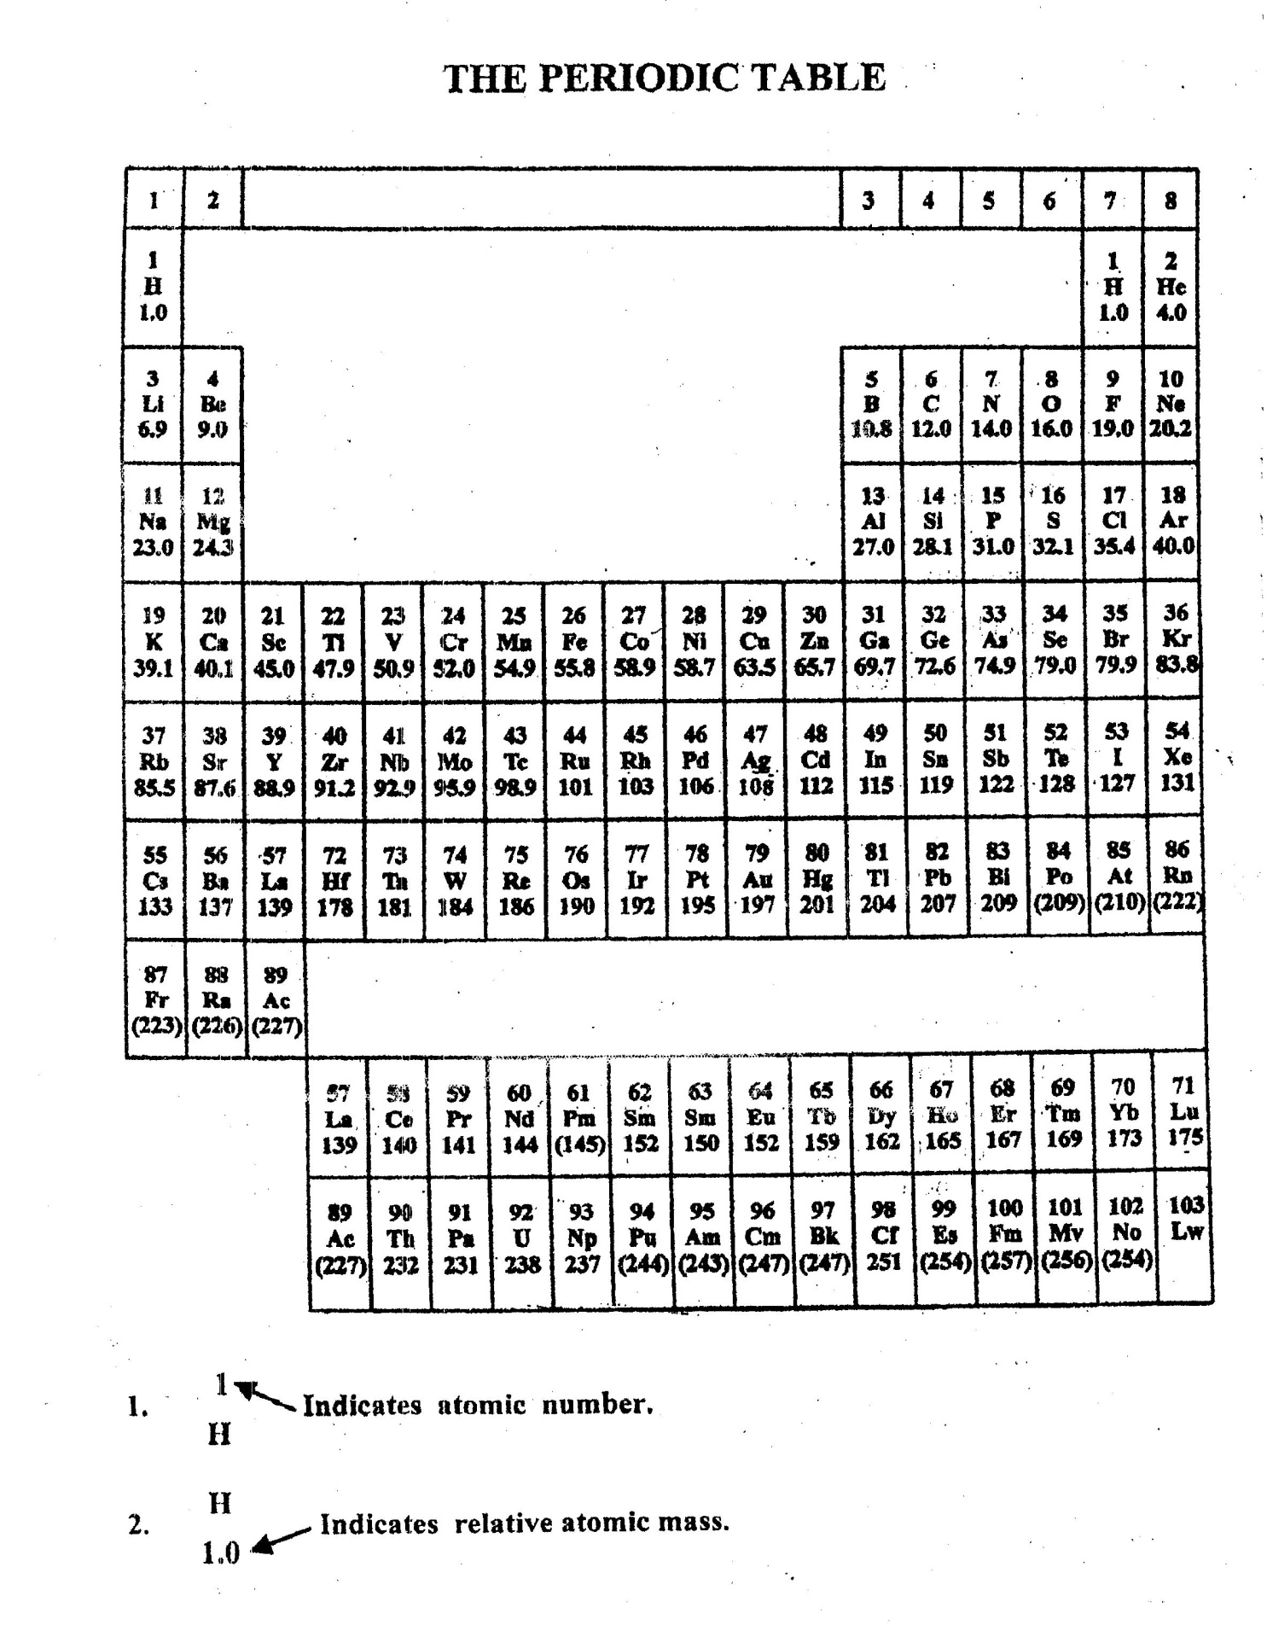
END

